Last Updated July 12, 2018
Version 1.1

Web Portal User Guide
SSRS 2016 for WITS
Applies to:
WITS Version 18.0+
Microsoft® SQL Server® Reporting Services (SSRS) 2016
Microsoft® SQL Server® 2016 Report Builder 3.0

WITS Customers
SSRS 2016 for WITS
Preface
PA WITS uses Microsoft® SQL Server® Reporting Services (SSRS) 2016 and Microsoft® SQL Server® 2016 Report Builder 3.0 as the primary reporting and analytics tool for WITS. SSRS is a web-based application allowing the development, storage, and generation of user-generated reports on data collected directly in WITS, in real time.

Intended Audience
This user guide has been prepared for all WITS customers using SSRS for reporting. Topics covered include new features in SSRS 2016, Web Portal system conventions, user interface items, and Report Builder installation instructions.
This document is provided “as-is” and information contained in this document, including URL and other website links or references, may change without notice. Microsoft and the trademarks listed at http://www.microsoft.com on the “Trademarks” webpage are trademarks of the Microsoft group of companies. All other marks are property of their respective owners.

System Requirements
WITS and the SSRS Web Portal are web-based applications accessed through an Internet (web) browser using an Internet connection.

Internet Browsers
WITS is compatible with up-to-date versions of most modern Internet browsers such as:
- Mozilla Firefox
- Google Chrome
- Microsoft Internet Explorer version 10+
- Apple Safari

Contact Production Support
For access to PA WITS, please contact your organizations Agency Administrator. If you are the Agency Administrator and you are unable to grant access, please contact the PA WITS Service Desk at RA-DAPAWITS@pa.gov. The PA WITS Service Desk will only grant access to SSRS from requests made by your organizations designated Agency Administrator. Please read the section titled “Report Subscriptions” to determine whether your user’s requirement can be met by emailing their requested report on a set frequency without granting access to SSRS.
In addition, WITS Production Support provides assistance with the following SSRS items:
- Access to PA WITS reports.
- Troubleshooting problems that users experience when navigating in SSRS or Report Builder
- Assists with determining accuracy of reports
If you need assistance related to SSRS, email WITS Production Support at RA-DAPAWITS@pa.gov. When contacting WITS Production Support for assistance with a report, please provide the logged in username, report title and a description of the folder path where the report is stored. If an error message occurs, please provide steps leading up to the error message and the actual wording of the error message.

Contents
Intended Audience i
System Requirements i
Internet Browsers i
Contact Production Support i
Part 1: New Features and Changes 1
New Terminology 1
New Features 1
Benefits 3
Items Not Changing 3
Part 2: Reporting Services Web Portal (SSRS Report Manager) 5
Report Services Overview 5
Major Components of Every SSRS Instance 5
Web Portal 6
How to Access the Web Portal 7
Web Portal User Interface 8
Web Portal User Interface Elements 9
Report Viewer 13
Upload and Share Reports and Report Parts 14
Download and Share Report Files 14
How to Upload Files on the Web Portal 14
How to Change the Data Source for a Report or Shared Dataset 15
Report Subscriptions 18
How to Create a New Subscription 18
Snapshots 22
Part 3: How to Open Report Builder 23
Option 1: Create a New Report 23
Option 2: Open a Saved Report (Edit a Report) 23
Open in Google Chrome 24
Open in Internet Explorer 26
Open in Firefox 27
Part 4: How to Install Report Builder 29
Download Steps 30
Open Report Builder Directly from Computer 35
Connect to a Report Server 35
Add a Data Source 36
Part 5: Error Messages 40
Invalid Data Source 40

New Features and Changes

New Terminology
- Web Portal: Formerly called Report Manager.
- Paginated Reports: This term refers to regular reports (in previous versions) and is used to differentiate between mobile reports and regular report types.

New Features
Web Portal: This is the new report server manager which replaces the previous version (known as Report Manager). The Web Portal includes new features such as Mobile Reports and Key Performance Indicators (KPIs). For more information, see Web Portal on page 5.
Figure 1-1: Web Portal Browse Page
Mobile Reports: Mobile Reports are built using Microsoft’s free SQL Server Mobile Report Publisher tool and are optimized for mobile devices with a responsive layout that adapts to different screen sizes and orientations. This tool is downloaded to users’ computers where users can upload their own data from an Excel spreadsheet or connect to their Reporting Services server (Web Portal) and use shared datasets. These reports can be saved locally or published to the Reporting Services server. Please note, instructions for building mobile reports are not included in this document.
NOTE • Microsoft SQL Server Mobile Report Publisher is required to build mobile reports. Click the following link to download the free application from Microsoft: https://www.microsoft.com/en-us/download/details.aspx?id=50400.
Figure 1-2: SQL Server Mobile Report Publisher
Download Button: This button takes users to Microsoft’s website to download supported applications such as Report Builder, Mobile Report Publisher, Power BI Dashboard, and Power BI Mobile.
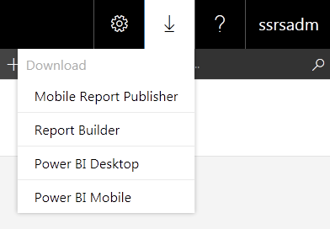
Figure 1-3: Download Button
Favorites Tab: The Favorites tab is a new folder that stores linked copies of users’ “favorite” report items. Users can mark report items as their “favorite” which automatically creates a linked copy within the Favorites tab and those items will be marked with a star. This saves time, as users will not have to navigate to the report’s folder to run the item. This feature is especially helpful for reports users run frequently. To learn how to add items to the Favorites tab, see Favorites on page 8.
Figure 1-4: Favorites Tab
To learn more about new features included in SSRS 2016, please click the following link: https://docs.microsoft.com/en-us/sql/reporting-services/what-s-new-in-sql-server-reporting-services-ssrs#whats-new-in-sql-server-2016.

Benefits
With the new Microsoft SQL Server 2016, users can now open (or launch) the Report Builder tool from all modern browsers. This is an improvement from the previous versions where Report Builder access was only available through Internet Explorer. For instructions on opening Report Builder from your browser, see How to Open Report Builder on page 22. Additional information on supported browser versions can be found by clicking the following link: https://docs.microsoft.com/en-us/sql/reporting-services/browser-support-for-reporting-services-and-power-view.
NOTE • Access to report builder now requires a one-time installation on users’ local machine.

Items Not Changing
When WITS customers update to SSRS 2016, the following features will not be affected and will function as they did in the previous version of SSRS. These features include:
- SSRS Model
- Model Item Security
- Roles
- Existing Reports (ad hoc and canned)
All existing reports (ad hoc and canned) that currently work in SSRS 2012 will continue to work in SSRS 2016 as the SSRS model is not changing.

Reporting Services Web Portal (SSRS Report Manager)

Report Services Overview
PA WITS uses Microsoft® SQL Server® Reporting Services (SSRS) 2016 and Microsoft® SQL Server® 2016 Report Builder 3.0 as the primary reporting and analytics tool for WITS. SSRS is a web-based application allowing the development, storage, and generation of user-generated reports on data collected directly in WITS, in real time.
SSRS access requires a WITS login, password, and role assignments, so administrators have full control over who can access the reporting database, as well as the level of access users have to the data and tools contained within SSRS. In addition, when state or agency administrators disable a user’s WITS login, that user will be blocked from accessing SSRS.
Users with appropriate roles are able to quickly create reports using Report Builder and make them available through the Web Portal to users with different levels of security. The Web Portal offers interactive ways to manipulate and view data within a report using its set of features and functions. End users can apply filters, select from drop-down lists, perform searches, and save and export filtered reports. Subscription services allow individuals to receive periodic copies of reports via secure e-mail, so even if a person has no access to SSRS, they may still receive updated reports on a periodic basis.

Major Components of Every SSRS Instance
- Web Portal (formerly called Report Manager): web-based administrative component that gives users the ability to control how reports are organized and distributed, including report security and subscription management. Administrators control access to the Web Portal by granting SSRS roles to users’ System Accounts in WITS, and can set permissions for individual items and folders within the Web Portal.
- Report Viewer: SSRS web-based component that allows users to view published reports within web browsers.
- Report Builder: the SSRS tool that gives users the ability to build reports. Users may install this application on their computer to edit and create reports built using Report Builder (except for canned reports developed by DDAP).
- Live WITS Database: central repository of all data collected in each WITS instance.
- SSRS Reporting Database: an exact copy of the Live WITS Database used to generate SSRS reports. This database is updated almost instantaneously with a new database backup (using AlwaysOn technology), which allows for real time reporting.
- SSRS Web Server: the server which stores the SSRS database of user-generated reports as well as serves the web-based application components. The report server is a resource used for storing items such as, saved and published reports, shared data sources, report parts, shared datasets, and shared subscriptions. When using report builder, there are two report servers you may connect to: training site and production site.
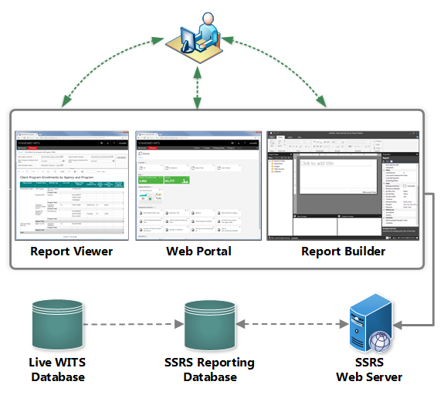
Figure 2-1: SSRS Components

Web Portal
The Web Portal is an administrative component that gives users the ability to control how reports are organized and distributed, including report security and subscription management. Administrators control access to the Web Portal by granting SSRS roles to users’ System Accounts in WITS, and can set permissions for individual items and folders within the Web Portal.
Web Portal Capabilities:
- View, search, print and subscribe to reports
- Create, secure and maintain the folder hierarchy to organize items on the server
- Configure role-based security that determines access to items and operations
- Configure report execution properties, report history and report parameters
- Create shared schedules and shared data sources to make schedules and data source connections more manageable
- Create data-driven subscriptions that send out reports to a large recipient list
- Create linked reports to reuse and re-purpose an existing report in different ways
- Download common tools such as Report Builder and Mobile Report Publisher
- Create KPIs

How to Access the Web Portal
Users with SSRS roles have two (2) options to access their site’s Web Portal.

Web Portal Access: Option 1
Users with SSRS roles will be able to view the SSRS Reports link located at the top right section in WITS. Clicking the SSRS Reports link will then open SSRS Web Portal in a new browser tab.
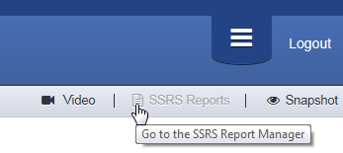
Figure 2-2: SSRS Reports link in WITS

Web Portal Access: Option 2
In addition, users may log directly into the Web Portal by accessing a Production or Training site URL.
- In a web browser, type the Web Portal URL and then enter your WITS login information.
WITS Site | Web Portal URL
Production | https://reports.witsweb.org/InstanceName
Training | https://training-reports.witsweb.org/InstanceName

Web Portal User Interface
The Web Portal is a web-based report access and management tool that users can access through your web browser. Items contained in the Web Portal typically include folders, reports (linked reports), data sources, datasets, report models and the My Reports folder.
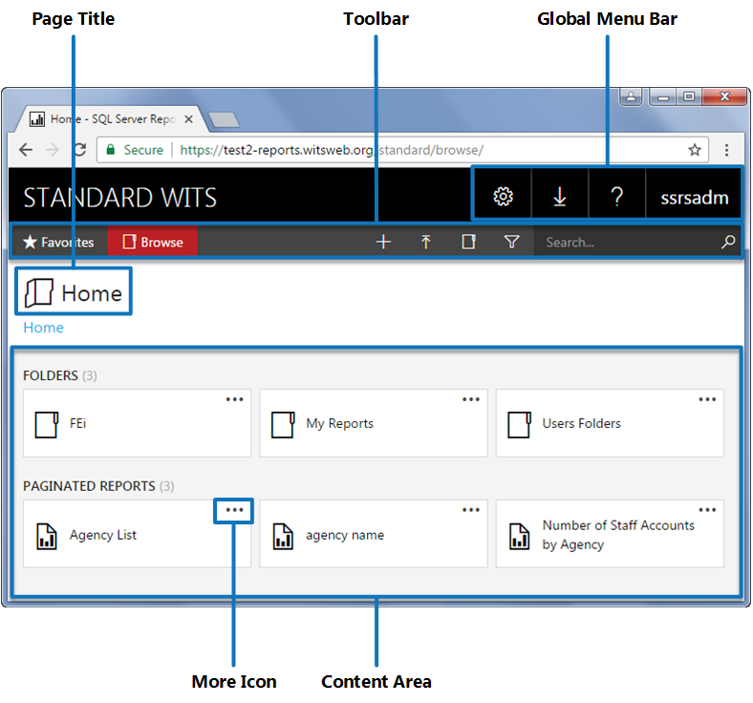
Figure 2-3: Reporting Services new Web Portal home page; Tile layout
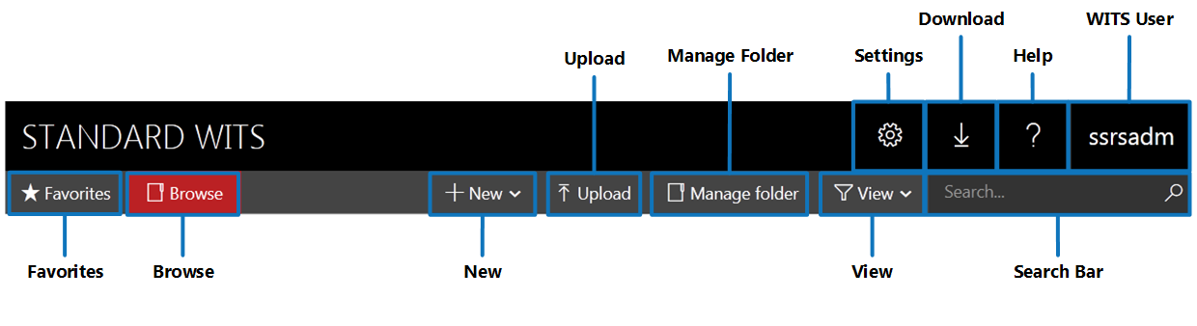
Figure 2-4: Reporting Services new Web Portal Icons, Standard Size
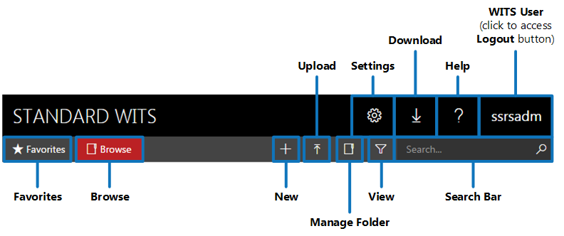
Figure 2-5: Reporting Services new Web Portal Icons, Compact Size

Web Portal User Interface Elements
Table 2-1: User Interface Items within the Web Portal
Element | Description
Favorites | [New Feature]  Stores a linked copy of reports and other items inside the Favorites folder for users to easily access without having to navigate the report path. Items marked as “favorite” will display a star icon.  - To add an item to your Favorites folder, click the more button (or the three dotted lines).  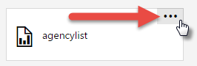  - Then click Add to Favorites.  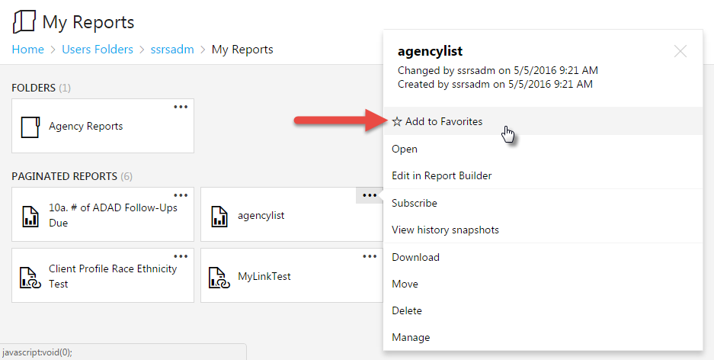
Browse | Click to return to the Home Page.
New | Add new report items; click to open the drop-down menu with the following options:  - Folder  - KPI  - Mobile Report  - Paginated Report  - Dataset  - Data Source | 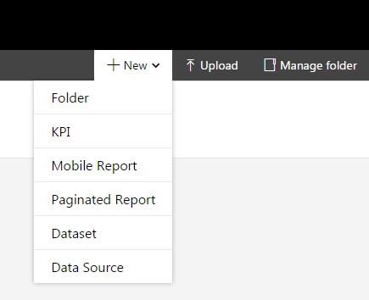
Upload | Opens file explorer to find and select a file to upload. Types of files that can be uploaded include:  - Report Builder Report File (.rdl)  - Report Builder Shared Dataset (.rsd)  - RSC File (.rsc)  - SQL Server Mobile Report (.rsmobile)  - Adobe Acrobat Document (.pdf)  - Microsoft Word Document (.docx)  - Microsoft Excel Worksheet (.xlsx) | 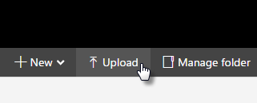
Manage Folder | Manage settings for the current folder location.
View
View | Click the View button to open a drop-down menu with options for managing how report item are displayed:  - Tiles  - List  - Show hidden items  By default, the Tiles layout is selected. | 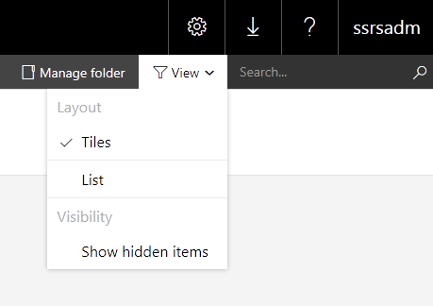
Select the List layout to view additional information about each report item, such as Description, Size, Modified date, and Modified by.
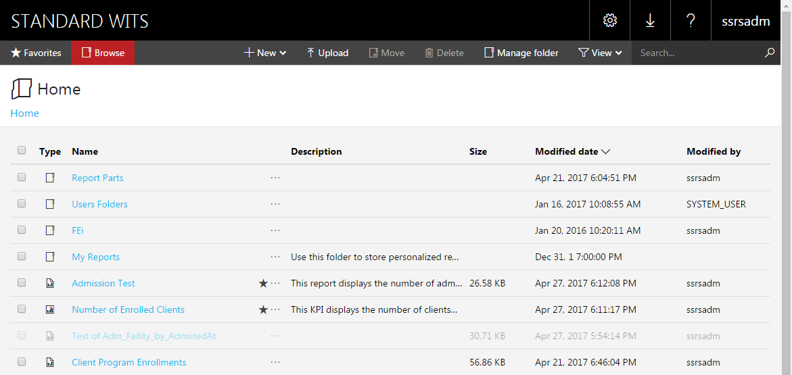
 | Click each column header to sort report items.
Click the check box on one or more report items to either Move or Delete.
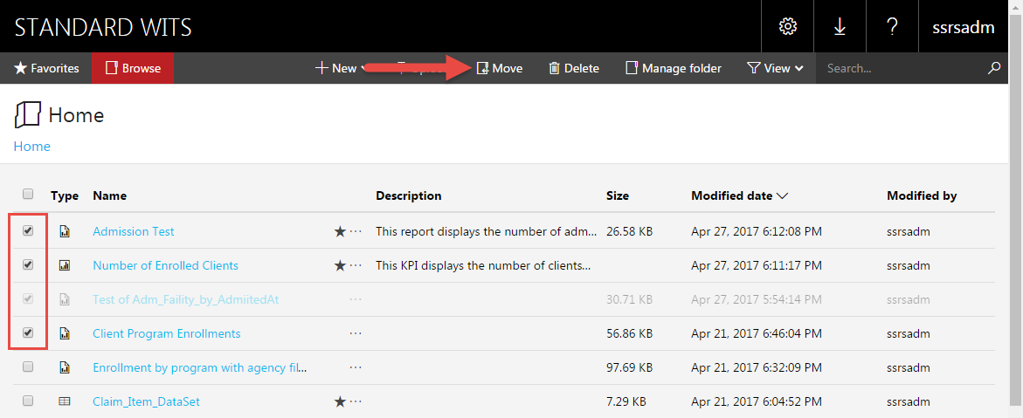
Settings | Click the Settings button to access the following options:  - My subscriptions  - Site settings | 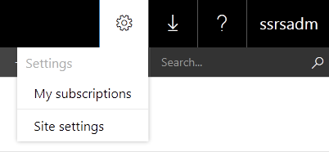
Download | Click the Download button to view a drop-down menu with free applications available to install on your computer:  - Mobile Report Publisher  - Report Builder  - Power BI Desktop  - Power BI Mobile  Clicking each option will open a new browser tab with download information from Microsoft’s website. These applications only need to be downloaded one time.
Help | Click the Help button to open a drop-down menu with the following options:  - Getting started  - Community  - About SQL Server Reporting Services | 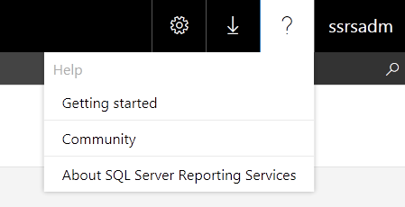
WITS User | Displays the User ID of the WITS staff member; click to access the Logout button.

Report Viewer
Report Viewer is a user-facing application that runs directly in a web-browser and allows end-users to view reports created in Report Builder including canned reports developed by DDAP. The report viewer does not require any additional software or plug-ins to operate, and can be viewed anytime from any Internet-connected computer.
Although simple in design, report viewer provides a powerful set of features that can make reports more informative and useful. With features like filters, lists and search functionality, end-users can interact with reports by manipulating the way the data is presented and organized, making reports more engaging and useful. In addition, report viewer allows end-users to export the reports in a variety of file formats including Excel, PDF, Word, PowerPoint, TIFF file, MHTML (web archive), CSV (comma delimited), XML file with report data, and Data Feed.
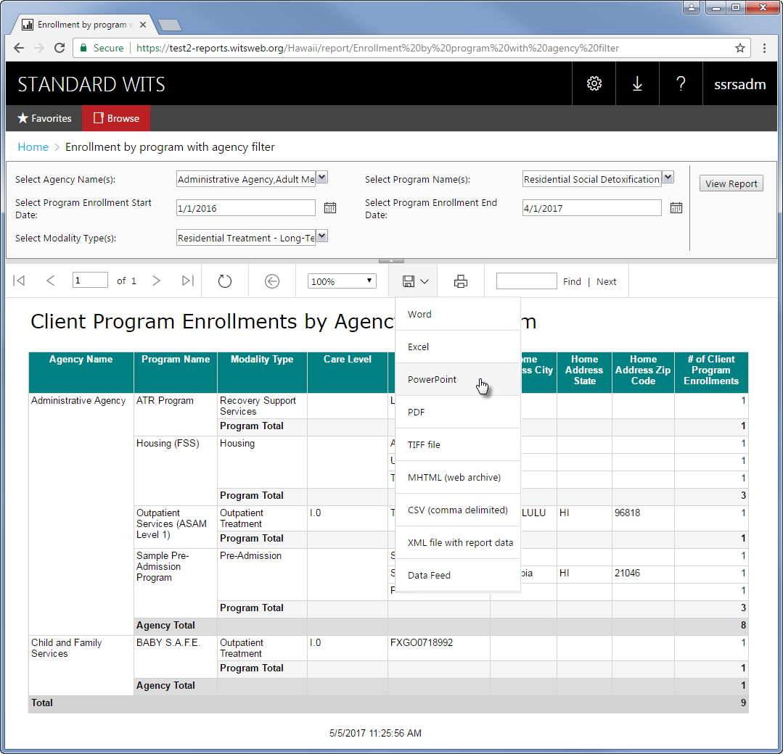
Figure 2-6: Report Viewer

Upload and Share Reports and Report Parts
On the Web Portal, files can be shared between your training site instance and your production site instance, and also between other WITS customers. Types of files include:
- Report Builder Report File (.rdl)
- Report Builder Shared Dataset (.rsd)
- RSC File (.rsc)

Download and Share Report Files
- To share a file on the Web Portal, click the item’s drop-down menu and select Download.
- Save the file to your computer.

How to Upload Files on the Web Portal
On the Web Portal, files can be shared between your training site instance and your production site instance, and also between customers.
- On the Web Portal, click the Upload button located in the tool bar.
Figure 2-7: Web Portal Tool Bar, Upload File
- Select a file then click Open.
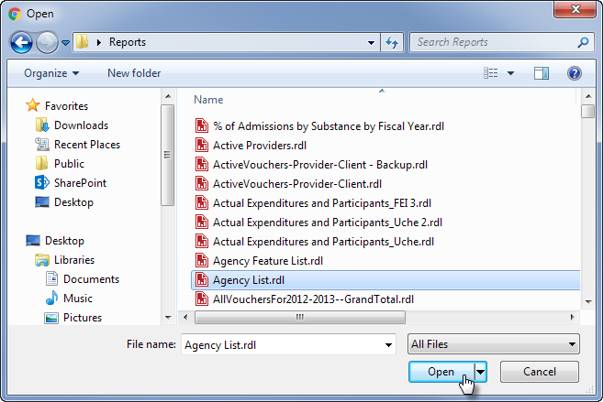
Figure 2-8: Upload File, click Browse

How to Change the Data Source for a Report or Shared Dataset
When reports and datasets are shared between WITS customers, the data source connection will need to be updated to your instance’s data source. By connecting to your instance’ data source, the shared report or dataset will display data collected from your WITS instance. If you forget to update the data source connection, the report or dataset cannot run and will display the error message shown below in Figure 2-9.
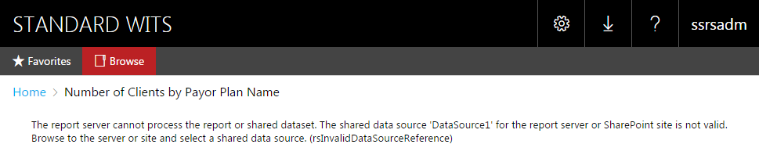
Figure 2-9: Invalid Data Source Error Message

Update the Data Source
- Click the report’s More icon to open the menu, and then select Manage.
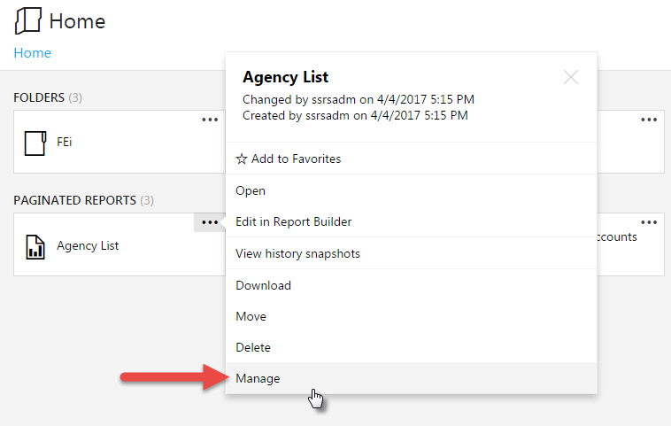
Figure 2-10: Report Menu Items, click Manage
- Click the Data sources tab.
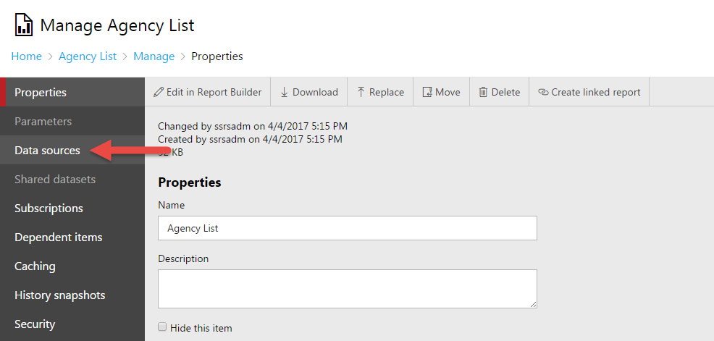
Figure 2-11: Report Properties, click Data sources
- On the Data sources tab, click the More icon.
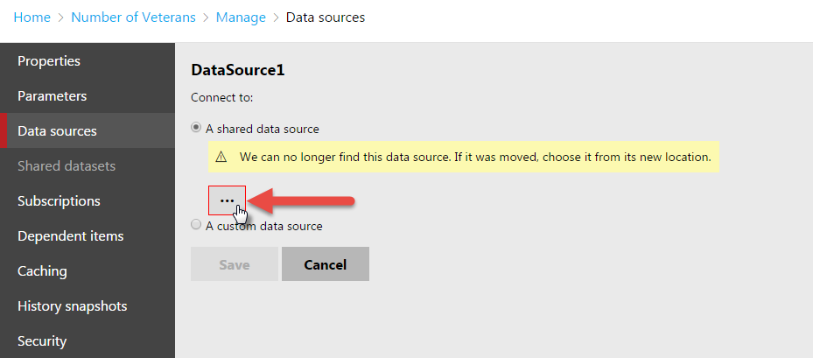
Figure 2-12: Data sources tab, choose a new data source
- Click the FEi folder.
Figure 2-13: Data source window, select FEi folder
- Click the Models folder.
Figure 2-14: Data source window, select Models folder
- Click the SSRS model.
Figure 2-15: Data source window, click the SSRS model
- Click Save.
Figure 2-16: Data sources tab, click Save
- Once the data source has been saved successfully, the Save button will become grayed out.

Report Subscriptions
Subscriptions are a great way to keep end users notified and informed with the latest data. After publishing the report to the report server, you can configure the report to run at a specific time, create a report history, and set up e-mail subscriptions. Once a user has been subscribed to a report, the process is completely automated so you don’t have to worry about sending out scheduled reports.
Additional Information on Report Subscriptions:
- Subscriptions and Delivery (Reporting Services): https://docs.microsoft.com/en-us/sql/reporting-services/subscriptions/subscriptions-and-delivery-reporting-services
- Create a Data-Driven Subscription (SSRS Tutorial): https://docs.microsoft.com/en-us/sql/reporting-services/create-a-data-driven-subscription-ssrs-tutorial

How to Create a New Subscription
- Click a report’s More icon, and then click Subscribe.
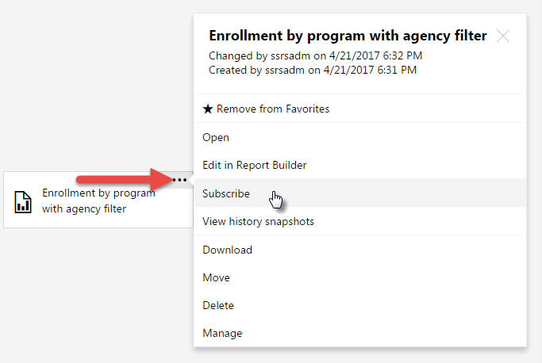
Figure 2-17: Report's More icon, Subscribe link
- On the New Subscription page, type the subscription’s Description and then complete the sections listed below.
Figure 2-18: New Subscription page

Type of Subscription
- Select either Standard or Data-driven (Standard is the easiest option).
Figure 2-19: Report Subscription Types

Schedule
- Select either a Shared scheduled (if available) or a Report-specific schedule.
NOTE • A shared schedule must be set up in the Site Settings before it can be selected.
Figure 2-20: Report Subscription Schedules

Report-specific schedule
- For a report-specific schedule, click Edit schedule.
- In the Schedule details section, choose whether to run the report on an hourly, daily, weekly, monthly, or one time basis. Additional fields will become available based on this selection.
Figure 2-21: Schedule Details
Figure 2-22: Daily Subscription Schedule
Figure 2-23: Weekly Subscription Schedule
Figure 2-24: Monthly Subscription Schedule
- Select the start and end dates (the end date is optional).
Figure 2-25: Subscription Start and End Dates
- Click Apply.

Destination
- Select E-mail.

Delivery Options (E-Mail)
- Type recipients’ e-mail address in the appropriate fields. Multiple e-mail addresses are separated by a semicolon (;).
- If the Include Report option is selected, choose the Render Format (Excel, PDF, Word, PowerPoint, TIFF file, MHTML (web archive), CSV (comma delimited), XML file with report data, or Data Feed).
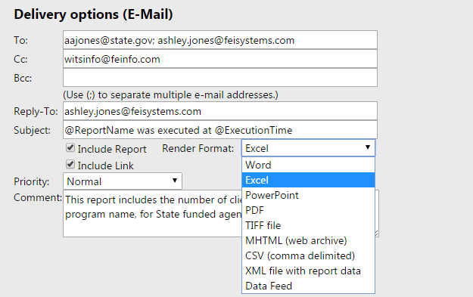
Figure 2-26: Report Subscription Delivery Options

Report Parameters (if applicable)
- If the report includes parameters, a value must be select for each field.
Figure 2-27: Report Subscription Parameters
- Click Create subscription.

Snapshots
The Snapshot feature is a very useful tool to save and view historical report data over time. This is especially helpful when reports are needed to view data from a specific moment. Report Snapshots can be created manually and/or created based on a schedule. If the report includes parameters, default parameter values must be specified before a snapshot can be created. By using the Snapshot feature, you can maintain a history of reports which are saved in the report’s history.
For more information on snapshots, click the following link: https://docs.microsoft.com/en-us/sql/reporting-services/report-server/create-modify-and-delete-snapshots-in-report-history.
For step-by-step instructions on creating snapshots, click the following link: https://docs.microsoft.com/en-us/sql/reporting-services/report-server/add-a-snapshot-to-report-history-report-manager.
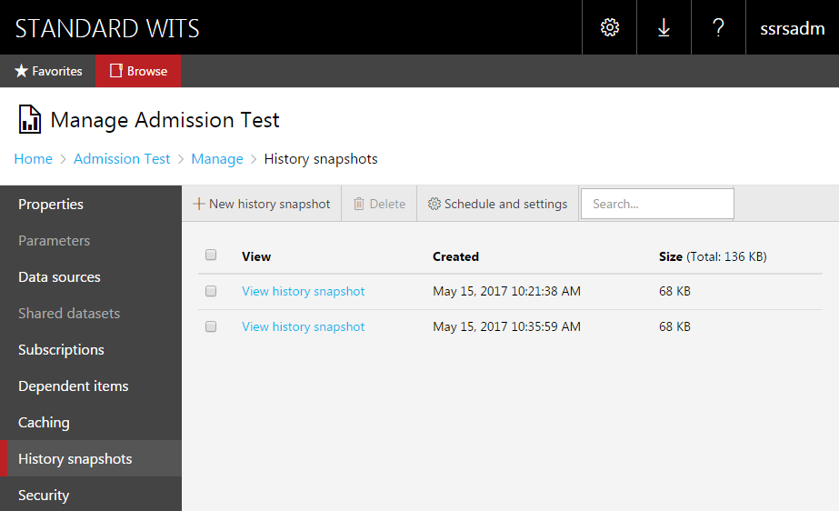
Figure 2-28: Report History Snapshots

How to Open Report Builder
NOTE • To open Report Builder from the Web Portal, users must first complete a one-time download and installation of Report Builder on to their computer. Once Report Builder is installed, users will just need to accept the prompt to launch it when asked. See How to Install Report Builder on page 28 for installation instructions.

Option 1: Create a New Report
Report Builder can be opened using any modern browser.
- On the Web Portal, click New, then click Paginated Report.
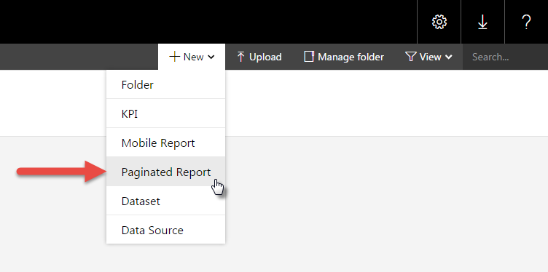

Option 2: Open a Saved Report (Edit a Report)
- Click on a report’s More icon to open the menu options.
- Click Edit in Report Builder.
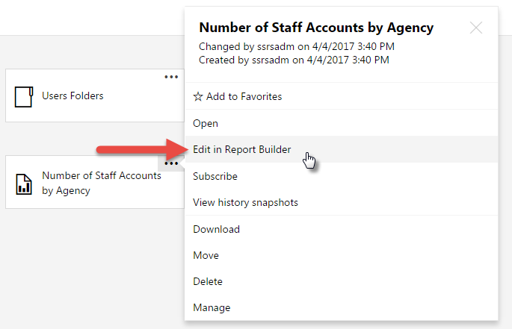

Open in Google Chrome
NOTE • If Report Builder has not been installed, close the top dialog box and click Get Report Builder on the bottom dialog box. See How to Install Report Builder on page 27 for installation instructions.
- In Google Chrome, use one of the options listed above to launch Report Builder.
- If Report Builder has been installed, click Open URL:ReportBuilder Protocol.
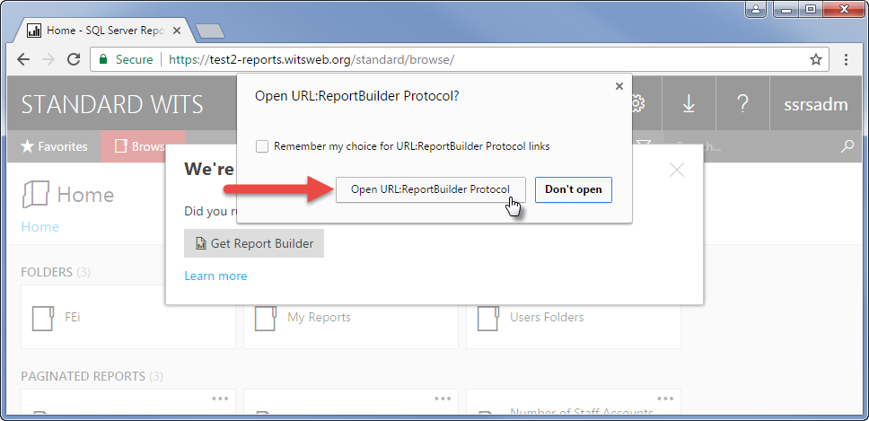
- Type your WITS User name and Password, then click OK.
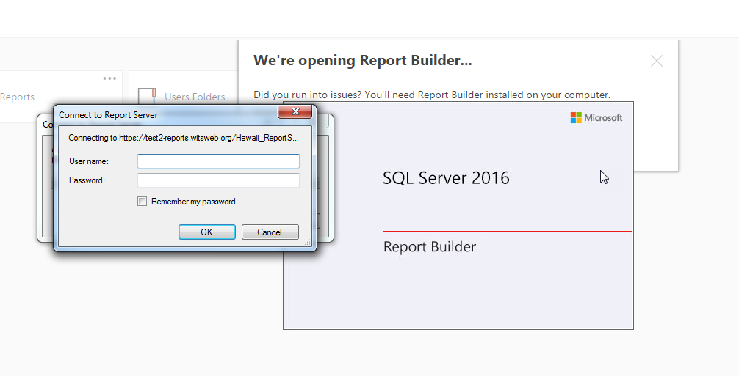

Open in Internet Explorer
NOTE • If Report Builder has not been installed, close the top dialog box and click Get Report Builder on the bottom dialog box. See How to Install Report Builder on page 27 for installation instructions.
- In Internet Explorer, use one of the options listed above to launch Report Builder.
- If Report Builder has been installed, click Allow.
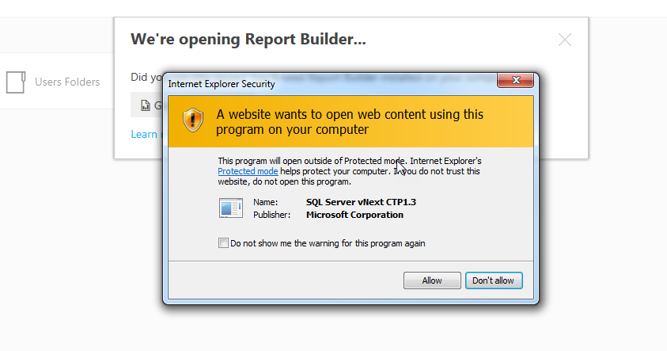
- Type your WITS User name and Password, then click OK.
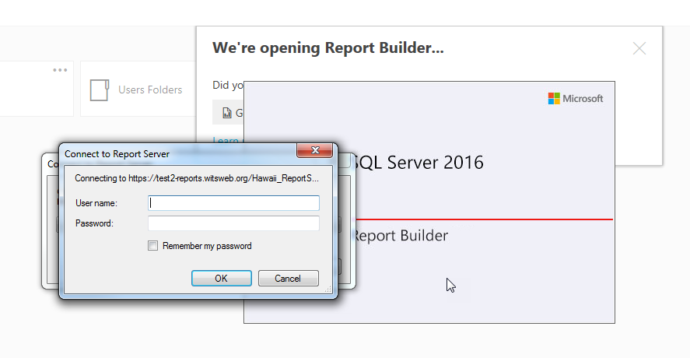

Open in Firefox
NOTE • If Report Builder has not been installed, close the top dialog box and click Get Report Builder on the bottom dialog box. See How to Install Report Builder on page 27 for installation instructions.
- In Firefox, use one of the options listed above to launch Report Builder.
- If Report Builder has been installed, click Open link, or click OK.
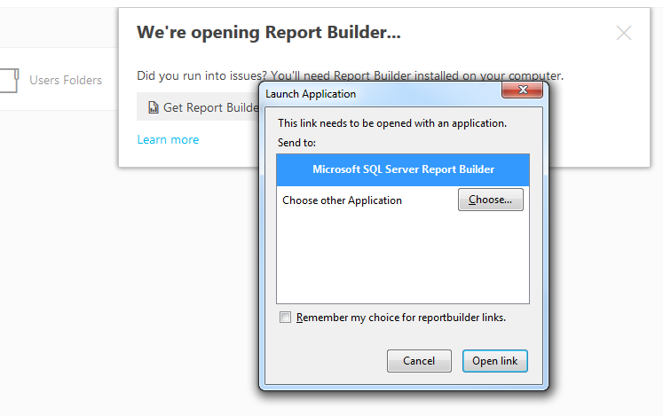
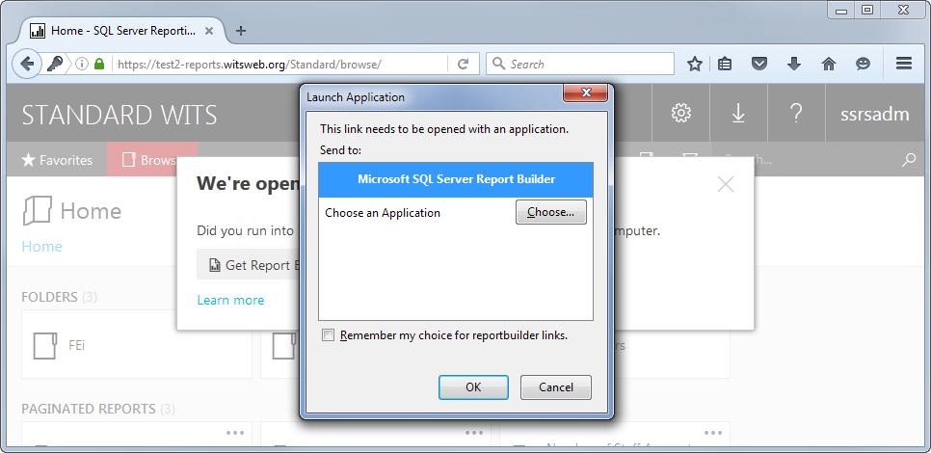
- Type your WITS User name and Password, then click OK.
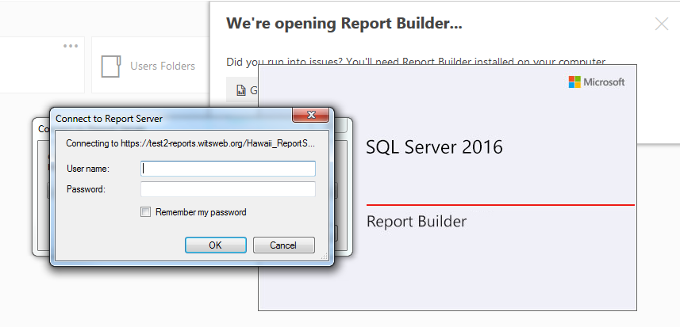

How to Install Report Builder
Install Microsoft® SQL Server® 2016 Report Builder
Download the free Report Builder application from Microsoft and add a desktop shortcut or pin the program to your computer’s taskbar.
Download URL: https://www.microsoft.com/en-us/download/details.aspx?id=53613
Version: | Date Published:
14.0.344.82 | 3/9/2017
File Name: | File Size:
ReportBuilder3.msi | 22.6 MB

Supported Operating System
Windows 10 , Windows 7, Windows 8, Windows 8.1, Windows Server 2008 R2, Windows Server 2008 R2 SP1, Windows Server 2012, Windows Server 2012 R2

Download Steps
- On the Web Portal, click the download button.
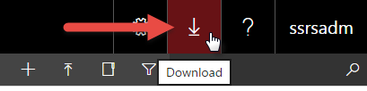
- On the drop-down list, click Report Builder.
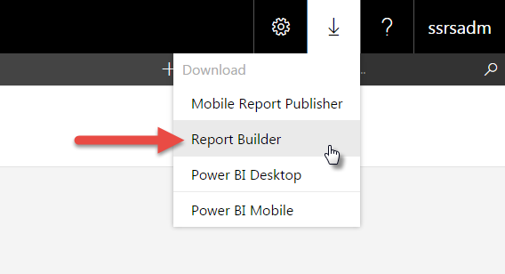
- This will open another browser tab with the following link:
https://www.microsoft.com/en-us/download/details.aspx?id=53613
- Click the Download button.
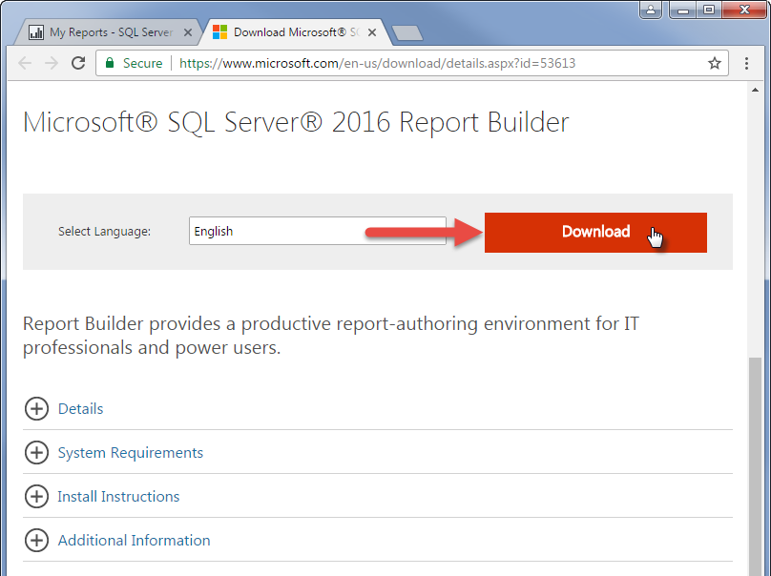
- Once the file has downloaded, click to open.
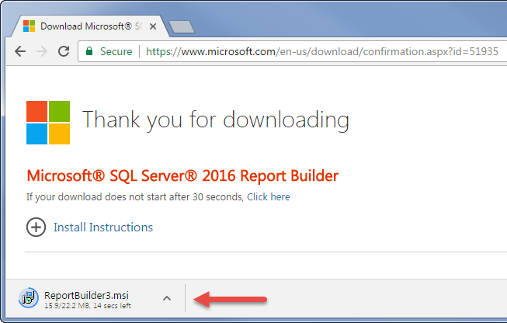
- On the Open File dialog box, click Run.
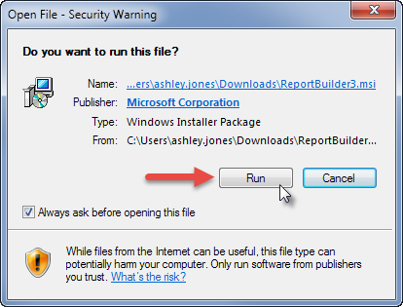
- On the Installation Setup dialog box, click Next.

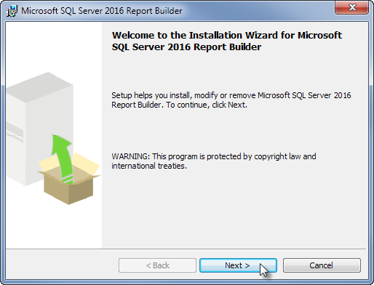
- On the License Agreement screen, read the license agreement, click accept, then click Next.
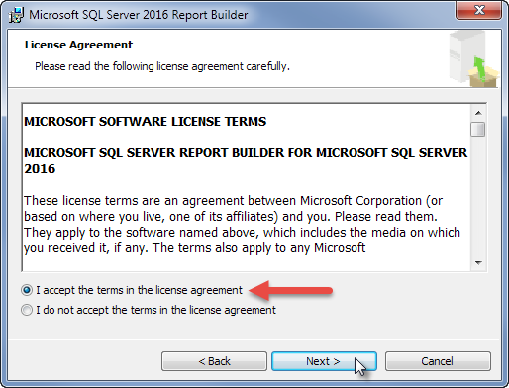
- On the Feature Selection screen, click Next.
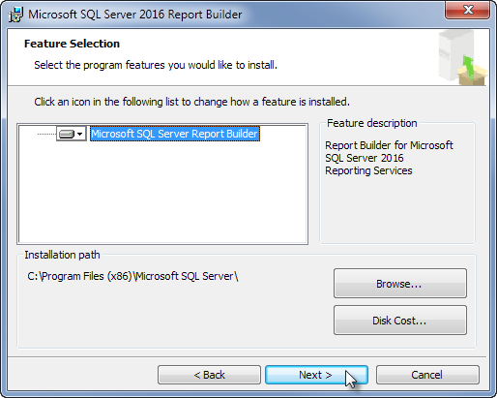
- On the Default Target Server screen, leave the URL section blank, and click Next.
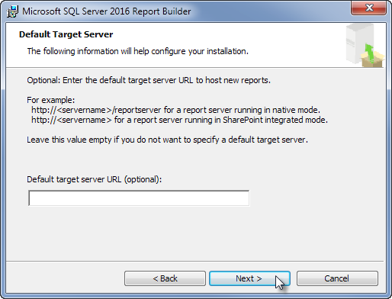
- Click Install. The installation may take several minutes.
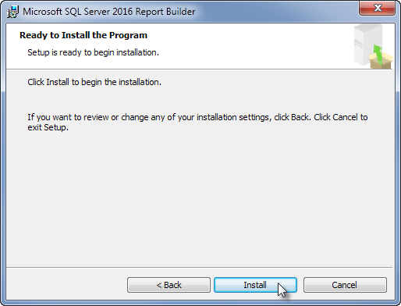
- Click Finish.
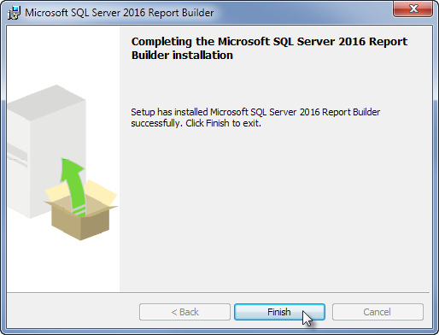

Update Windows Registry Settings
Effective June 16, 2018, individual staff members need to implement the following change on their computer to continue using Report Builder. There will be no impact to the other functionality of SSRS, running reports or creating/receiving subscriptions; this only impacts those who use Report Builder.

Background
Due to a vulnerability in the protocol, FEI/WITS has disabled TLS 1.0/SSL V3 on all application servers. As the next step, we will be disabling TLS 1.0/SSL V3 on SSRS servers as well. We have identified an issue with the SSRS Report Builder application breaking when TLS 1.0 is disabled on the server. Since the Report Builder application uses an older .NET 4.51, it will not use higher versions of TLS by default without modifying a registry setting on each user’s Windows install. Microsoft has not published plans to update Report Builder to a higher version of .NET, and we have found no other work around.

Action Needed
In order to force SSRS Report Builder to use TLS 1.1 and above and have it function properly, the following registry settings need changed on the user’s Windows install. This can be done by executing the following PowerShell commands with administrative privileges (Option 1), or by importing the attached Windows Registry setting file with RegEdit (unzip first), see attached instructions (Option 2). Without this registry change, Report Builder will cease to work once FEI/WITS has disabled TLS 1.0/SSL V3 on the SSRS servers on June 16, 2018.
Additional information:
- https://support.microsoft.com/en-us/help/3155464/ms16-065-description-of-the-tls-ssl-protocol-information-disclosure-vu
- https://success.outsystems.com/Support/Enterprise_Customers/Maintenance_and_Operations/(.NET)_Enable_SSL_Protocols_for_your_Integrations_-_TLS_1.1_and_TLS_1.2
- https://johnlouros.com/blog/enabling-strong-cryptography-for-all-dot-net-applications

Option 1: Execute PowerShell Commands
Requirement: Administrative Privileges for your computer.
PowerShell commands to enable SchUseStrongCrypto in the registry:
New-ItemProperty -path 'HKLM:\SOFTWARE\Microsoft\.NETFramework\v4.0.30319' -name 'SchUseStrongCrypto' -value 1 -PropertyType 'DWord' -Force
New-ItemProperty -path 'HKLM:\SOFTWARE\Wow6432Node\Microsoft\.NETFramework\v4.0.30319' -name 'SchUseStrongCrypto' -value 1 -PropertyType 'DWord' -Force

Option 2: Import Windows Registry Setting File
Follow the steps below:
- Double-click the following file “SchUseStrongCrypto.zip”.
- On the Open Package Contents window, click Open.
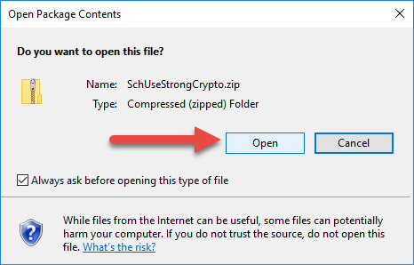
- Click Extract all or Export (depending on your PC version).
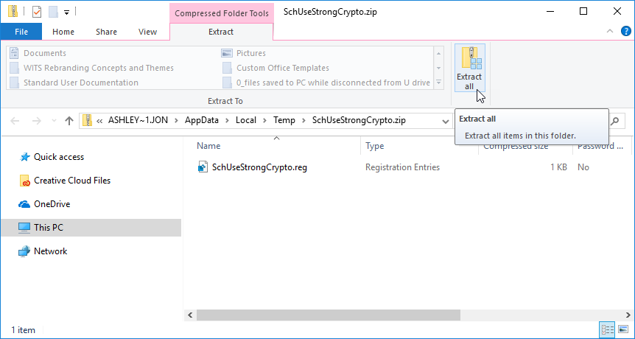
Figure 5-2: Extract all or Export
- Click Browse.
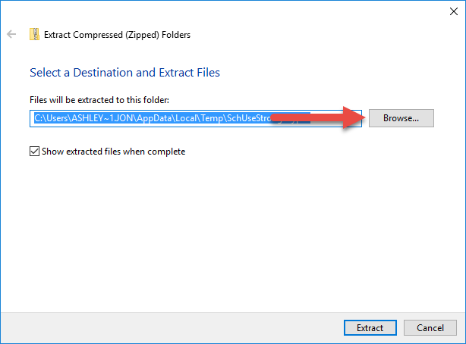
Figure 5-3: Click Browse
- Choose a location for the extracted files. (In this example, a folder was created called “SSRS Update”.)
- Click Select Folder.
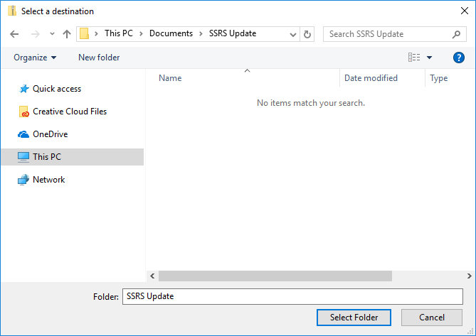
Figure 5-4: Select Folder
- Click Extract.
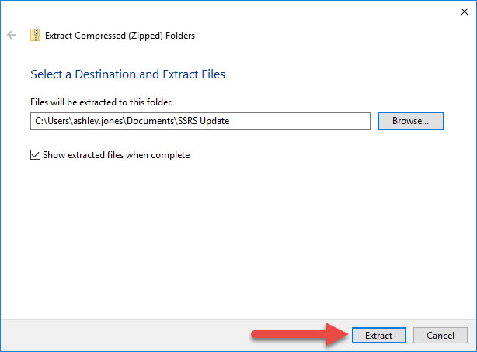
Figure 5-5: Click Extract
The extracted file is now saved in the destination folder.
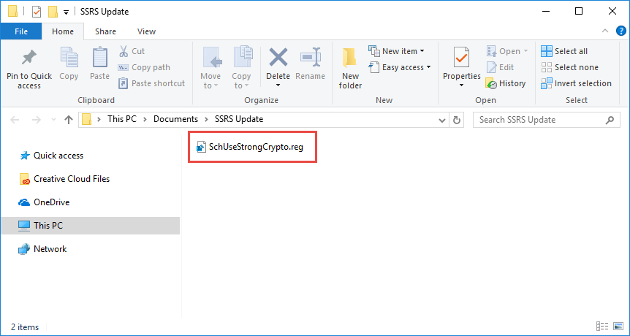
Figure 5-6: Extract File Location “SchUseStrongCrypto.zip”
- Open the program, “Registry Editor”.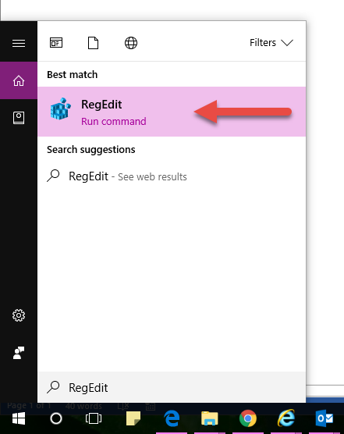
Figure 5-7: Open the RegEdit Program on your computer
- In Registry Editor, click File and then click Import.
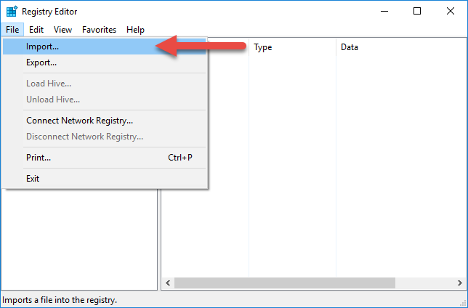
Figure 5-8: Click File, then click Import
- Navigate to the location where the extracted “SchUseStrongCrypto.zip” file was saved and click the file.
- A confirmation message similar to the message below should appear. Click OK.
You have completed the import and you can close Registry Editor.
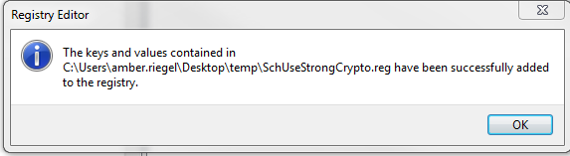

Open Report Builder Directly from Computer
- On the Start menu, click All Programs, then search for Microsoft SQL Server 2016 Report Builder.
- Click Report Builder.
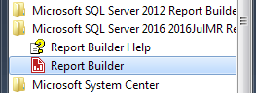
Figure 4-1: Start menu, Report Builder application
- When Report Builder launches, close the Getting Started dialog box, if open.

Connect to a Report Server
- In the Status Bar, click the Connect link located at the bottom left corner of Report Builder.
Figure 4-2: Connect to a Report Server
- On the Connect to Report Server dialog box, select or type your report server name following the format below. Then click Connect.
WITS Site | Report Server Name
Production | https://reports.witsweb.org/InstanceName_ReportServer
Training | https://training-reports.witsweb.org/InstanceName_ReportServer

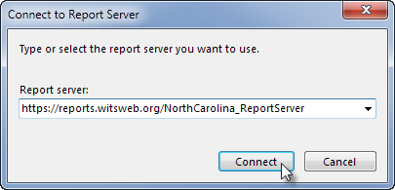
Figure 4-3: Connect to a Report Server, type or select your Report Server name
- Next, type in your WITS User ID and Password. Then click OK.
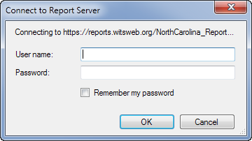
NOTE • Your user name and password are the same as your WITS User ID and Password.
Three (3) failed log in attempts will disable your account.
Figure 4-4: Connect to a Report Server by entering your WITS User ID and Password

Add a Data Source
To connect to the report model, follow the steps below.
- In the Report Data area, right-click on the Data Sources folder and select Add Data Source.
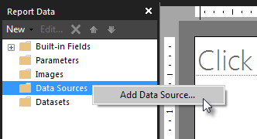
Figure 4-5: Right-click the Data Source folder and select “Add Data Source”
- This will open the Data Source Properties dialog box.
- On the Data Source Properties dialog box, select the option Use a shared connection or report model (note: this option is selected by default).
- Click, Browse.
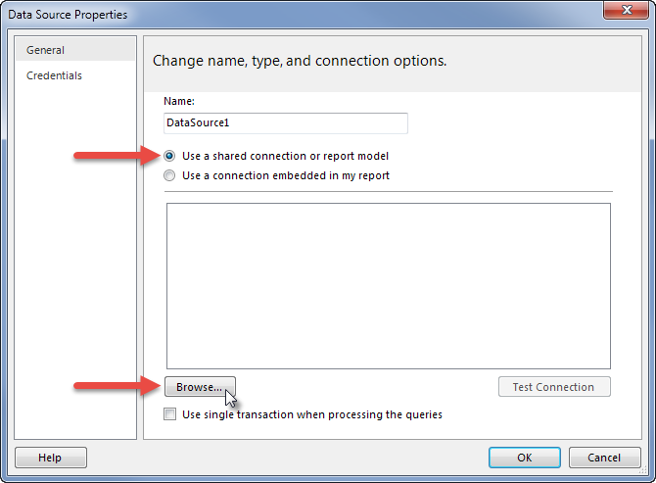
Figure 4-6: Data Source Properties dialog box
- Next, search for the data source. The data source is found by navigating through the following folders:
  - FEi > Models > Wits.Ssrs.Models.
  - To open a folder, double-click the folder name, or click the “Open” button.
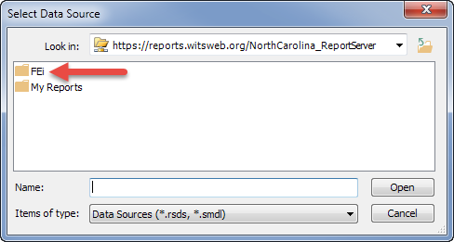
Figure 4-7: Select Data Source, open the “FEi” folder
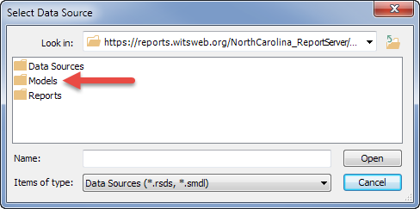
Figure 4-8: Select Data Source, open the “Models” folder
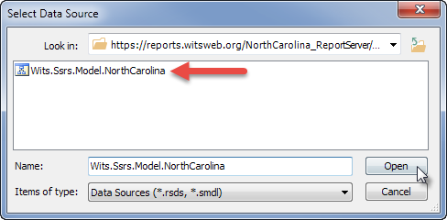
Figure 4-9: Select Data Source, click the WITS SSRS Model
- On the Data Source Properties box, click OK.
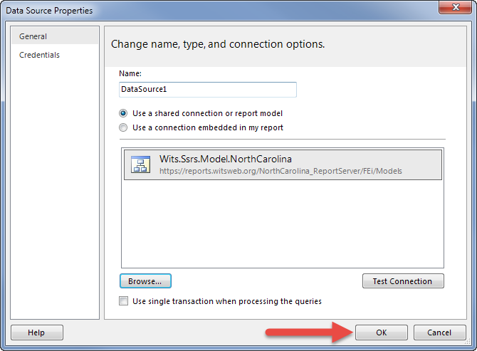
Figure 4-10: Data Source Properties
- In the Report Data section, notice the new Data Source has been added.
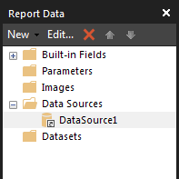
Figure 4-11: Data Source Connection

Error Messages

Invalid Data Source
If you receive the following error message, see How to Change the Data Source for a Report or Shared Dataset on page 14 for steps to update the data source.
Figure 5-1: Invalid Data Source Error Message

Error Message Text:
The report server cannot process the report or shared dataset. The shared data source 'DataSource1' for the report server or SharePoint site is not valid. Browse to the server or site and select a shared data source. (rsInvalidDataSourceReference)

More information on exporting to Excel: https://docs.microsoft.com/en-us/sql/reporting-services/report-builder/exporting-to-microsoft-excel-report-builder-and-ssrs
More information on Data Feeds: https://docs.microsoft.com/en-us/sql/reporting-services/report-builder/generating-data-feeds-from-reports-report-builder-and-ssrs

